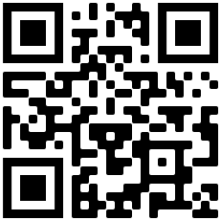
TAKE AND MAKE: Zines

Watch on YouTube by entering this URL or scanning the QR Code: https://bit.ly/ppldzine

What’s a zine? A zine (pronounced “zeen”, like magazine) is a do-it-yourself publication that can incorporate lots of forms of art, writing, and design. Often reproduced on a copier, zines are a way to get your ideas and vision out into the world outside of the confines of mainstream publishing.

Why make a zine? While zine-like publications have been around for hundreds of years (think pamphlets, leaflets, or newsletters), today’s zines have their origins in sci-fi fandom and punk rock movements in the 1950s and 60s. They are a way to connect to others who share or might be interested in similar ideas, which was critical before the internet made connecting with others as easy as a web search. But zines are still relevant today – they offer a more physical, hold-in-your-hand way to share art, can be a great avenue for folks without access to traditional publication methods, and are relatively easy to make and distribute.

What’s in the kit?
- A mini-zine about zines and how to make them  - Collage materials | - A permanent marker  - A glue stick

You might also need scissors and can use any materials that you’d like to make your zine your own. Think stickers, fabric scraps, washi tapes, colorful markers, or anything you’d like to incorporate.

Formatting. We’ve included instructions for an 8-page mini-zine here to get you started, but there are lots of ways to make a zine. The most important thing is that your zine is the right size and shape to get your message across. Additionally, if you’re wanting to share your zine far and wide, it helps to have a use a format that’s easy to photocopy and reproduce. Here are a couple more ideas:
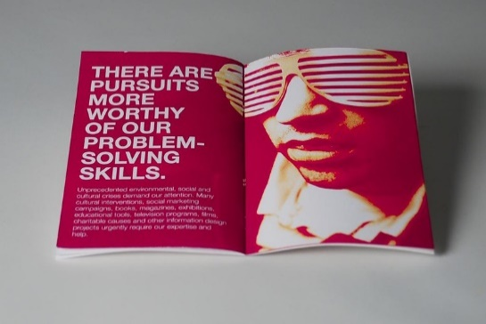  (CC BY 2.0 image via @colindunn on Flickr)  Booklet Zine – fold pieces of paper of any size in half and either staple or sew on the fold to bind. In this format, you can include as many pages as you want. These zines are great for poetry and long pieces of writing. | 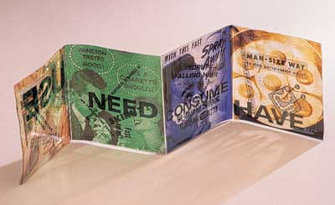  (CC BY-NC-ND 2.0 image via @enchiladaplate on Flickr)  Accordion Zine – Make an accordion fold by folding a piece of paper in half and then folding the edges back toward the center. These zines can have different content on the front and back of the paper.

Getting ideas and brainstorming. Not sure where to start? Lots of zines are about topics that are close to the zinester’s heart. Maybe you can share an important part of your heritage or culture, gush about the band you love, or compile some photos you’ve taken. Zines can be about anything, but sometimes that can be overwhelming too. Get some freewriting and doodles on paper to start and see where your creativity takes you. Here are some prompts and ideas to get you started:

- What does utopia look like?  - Talk to a friend. What topic would they most like to see a zine about?  - Tell us about a day in the life of your pet.  - You’re walking in the woods and encounter a monster! What do you do?  - Was there a day that changed everything for you? What happened? | - What food or recipe makes you think of your childhood?  - Tell us about your favorite tree.  - Who are you when you’re by yourself?  - Draw a comic about the object closest to your right hand.  - Review the latest book/movie/podcast/tv show that you hated.

Visuals! Don’t forget that zines don’t have to be writing alone – presenting your ideas visually can be exciting as well. While drawings can be fun, you don’t have to be a great artist to make a zine. You can incorporate magazine clippings, photos, and even things like graphs and charts to catch the reader’s eye. Lots of art forms including collage, painting, printmaking, and stamping can add flair to your message.

Copy machines. Part of the fun of zines is making copies to share – whether that’s giving them to friends, swapping with other zinesters, or leaving them in community book swaps. If you don’t have a home copier or printer, all library locations offer access to a copier for a small fee.

Now that you’ve got your ideas, visuals, and formatting all sorted out, you can get to zine making! If you share your finished zine on social media, be sure to tag us with #PPLDTakeandMake!

Library Resources and Links
- Whatcha mean, what’s a zine? by Mark Todd & Esther Pearl Watson
- How to Make Books by Esther K. Smith
- Stolen Sharpie Revolution: A DIY Resource for Zines and Zine Culture by Alex Wrekk (available on Hoopla)
- $100 and a T-Shirt: A Documentary About Zines in the Northwest (available on Kanopy)

Other Local Resources and Links
- Pikes Peak Zine Fest (pikespeakzinefest.com) – an annual local event celebrating zines
- Zine Library at Colorado College (libraryweb.coloradocollege.edu/library/specialcollections/zines/) – a local zine collection in the CC Special Collections
- Denver Zine Library (denverzinelibrary.org) – a lending library dedicated just to zines
- From A to Zine (fromatozine.com/) – more information about zines and how to use them for education

